Independent review of Without Walls’ impact as NPO from 2018 – 2021
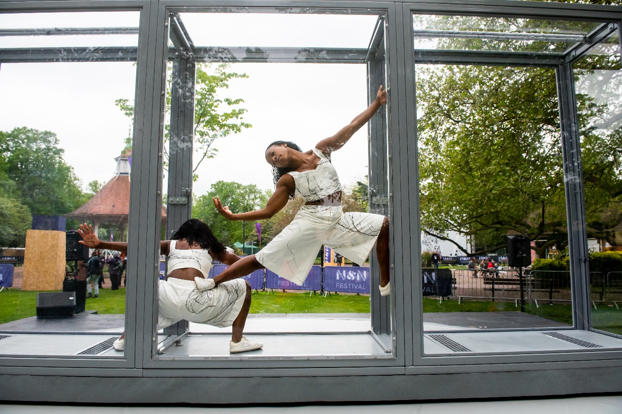
Bonded by Alleyne Dance © Lidia Crisafulli

Summary
Without Walls wishes to commission an experienced consultant/s to undertake a review of the impact of the Consortium since becoming an Arts Council England National Portfolio Organisation (NPO) in 2018. It is expected that the review will focus on the following key outputs:
- The documented impact Without Walls has had across the sector and identifying gaps or further areas to analyse
- The perception of Without Walls with key stakeholders and audiences
- Progress on the stated aims and commitments made in its Business Plan (2018 – 2023)
- How the work of Without Walls relates to Arts Council England’s 10- year strategy ‘Lets Create’ (2020-2030)
- The efficiency of the data collection and evaluation processes currently used to evaluate Without Walls’ work.

Background and context
Without Walls, now in its fifteenth year, has been an NPO of Arts Council England since 2018 and is currently preparing to apply for the next round of funding from 2023 onwards (for more information on Without Walls see Appendix 1).
Following an initial Impact Study conducted by BOP Consulting in 2016/7, this next report will develop further and provide an update on Without Walls impact on artists, festival partners and the wider sector since becoming an NPO as well as monitoring progress against agreed goals.
The report will also review Without Walls internal evaluation processes and those provided by external experts (i.e. The Audience Agency), and provide valuable insights in preparing the next NPO application, considering the degree to which Without Walls work aligns with Arts Council England’s 10-year ‘Let’s Create’ strategy. Further research projects are being planned for 2022/23 and information from this review may be used to identify key areas of study for subsequent research.

Process
An independent arts manager/researcher, consultant, partnership or agency is invited to review activity in all areas of Without Walls’s work since becoming an NPO. The review should link to the key outputs outlined above, with the following areas to be explored and responded to:
- Impact the Without Walls activity has had on supported artists
- Impact the Without Walls activity has had on its partner festivals and organisations
- Impact the Without Walls activity has had on the wider UK (and international) outdoor arts sector
- Impact the Without Walls shows have had on partners’ festival and event audiences
- How Without Walls is performing against key targets relating to sustainability and Equality, Inclusion and Diversity
- Any other areas of impact the Without Walls activity has had that are not directly related to the above
- Trends that may be identified when comparing the 2016/17 Impact Study to more recent evaluation data (bearing in mind that the membership of Without Walls and data collection has changed significantly since then)
- Value of the information and data gathered by Without Walls over the past four years, from audiences, artists, festival partners, Board members and staff members as well as the wider sector
- How the Consortium addresses the aims set out in the 5-year Business Plan and the degree to which these aims are being reached (see Appendix 2)
- How the activity of the Consortium addresses the aims outlined in the Investment Principles set out in Arts Council England’s 10-year ‘Let’s Create’ Strategy
- Which areas of activity may benefit from further in-depth research to be carried out in 2022/23

A range of documents, reports and data will be available to the consultant/s to review including but not limited to (please see Appendix 3 for a more extensive list):
- Without Walls Business Plan 2018 – 2023 & Arts Council Funding agreement
- Arts Council England Let’s Create Strategy 2020 – 2030
- Festival and Artist evaluation and monitoring forms
- Arts Council reporting, feedback and reports
- Financial reports
- Evaluation reports
- Selected Board papers
- Audience data from partner festivals and reports compiled by The Audience Agency (2013 – 2021)
- External Governance review
- Recently commissioned report on Without Walls work with Black, Asian and ethnically diverse artists and practitioners

It is anticipated that the review will mainly require desk research, though the consultant will also undertake primary research in the form of interviews or meetings with artists, Board members, Consortium partners, management staff, Arts Council representatives and other contributors. Interviews can be conducted in confidence and reported anonymously as required.
A list of possible interview candidates is included as Appendix 4.
A budget can be allocated to pay for the time of unsalaried interviewees or others for whom non-payment could be a barrier to participation in this review.

Outcomes
The consultant/s is required to write a report for, and make a presentation to, the Board summarising findings and making recommendations for any potential actions and future research projects.

Timescale
Without Walls would like the research to take place between November 2021 – February 2022, with an initial review of findings taking place in early February and a final report being presented to the Board in early March.

To respond to this brief, please submit a proposal outlining:
- How you would approach this brief indicating any issues for consideration
- The proposed methodology, setting out the steps you would take to deliver the work
- The skill and experience of the candidate/s including references and/or examples of previous work
- Estimated timetable for delivery and key deliverables
- Quotation for delivery of the work – we would expect the contract not to be more than £9,500 (inclusive of VAT), which includes any expenses and overheads. An additional budget will be made available to fund access and inclusion needs if required.

The ideal candidate/s will have:
- Demonstrable experience of the arts and cultural sector in the UK
- Ability to work collaboratively and achieve key deadlines
- Experience of undertaking consultancy work and relevant research methodologies
- Experience of analysing data, conducting interviews and presenting clear reports
- An understanding of Arts Council England’s funding streams and their Let’s Create strategy
- A record of delivering similar research projects
- An understanding of the outdoor arts sector

We welcome proposals from agencies and partnerships as well as individuals.

Members of the Board, including the Chair, Josephine Burns (Founder and Senior Associate of BOP Consulting) will support the delivery of this work alongside the XTRAX Management team. The candidate will be required to meet with them (online or in person) and report to them as part of the process.

Please send your proposal to Annika Edge, General Manager at annika@xtrax.org.uk
We are open to receiving submissions by video (of up to 10 minutes in length).

The deadline for receipt of tenders is 12 noon, 4 November 2021.
For further information or to set up an informal discussion before applying please contact Annika Edge at annika@xtrax.org.uk.

Appendix 1

Background
Established in 2007, Without Walls is the UK’s leading consortium of festivals and organisations dedicated to raising the profile of the UK Outdoor Arts sector, supporting new work by UK artists and presenting it at festivals and events across England and around the world.
Without Walls has grown from a partnership of five festivals in 2007 to a collective of 35 festivals and events, operating through three different networks:
- The Artistic Directorate – a network of (currently) eleven festivals and organisations who invest commissioning and development funds in new work alongside Without Walls and present the new shows at their events and festivals. This group of artistic leaders is collectively responsible for curating the artistic programme for Without Walls.
- The Touring Network Partnership – this group of 18 festivals present work created by Without Walls at festivals across England, many in areas of low engagement for the arts, reaching diverse new audiences
- The Creative Development Network – a new network of emerging festivals to whom Without Walls offers developmental support
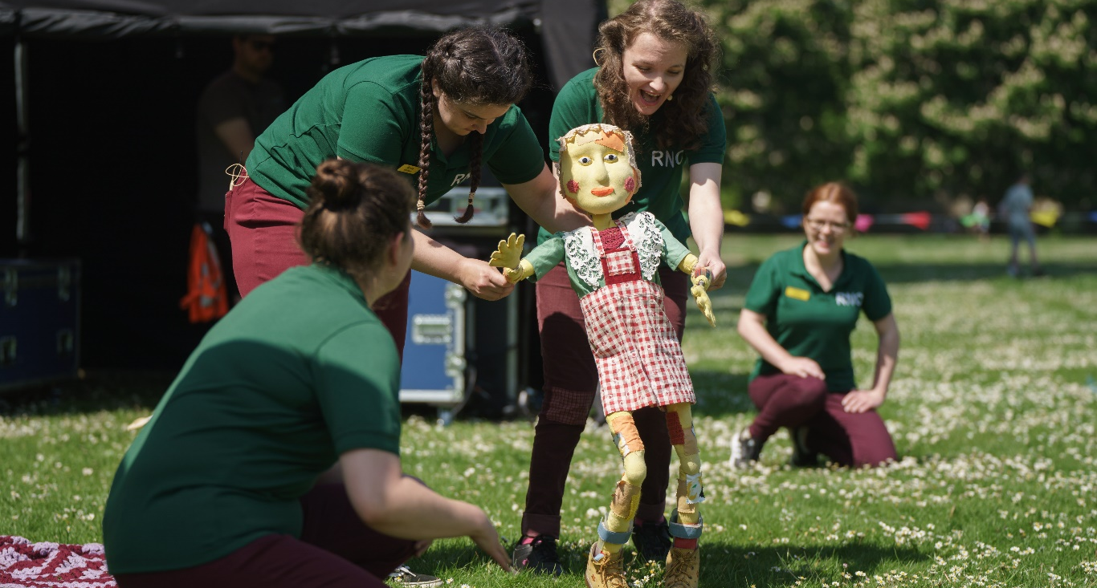
What Happened to You? by Nikki Charlesworth © Ash Mills
The operation of these groups is described in a well-developed Governance and Operational Framework Document which sets out the Terms of Reference for Board members, and members of each network.
Without Walls has supported over 200 shows by UK artists, and undertakes a range of strategic development work to support the development of ambitious outdoor arts work, including projects to promote diversity and inclusion for Black, Asian and ethnically diverse artists and audiences; initiatives to promote Deaf and disabled artists and audiences; a programme to support artists and festivals to address environmental responsibility; a wide range of audience development work, and numerous other strategic projects.
Without Walls programming aims to reflect the diversity of artists in the UK; 65% of the artists Without Walls has supported are based outside of London, 13% are Black, Asian or ethnically diverse led, and 8% are Deaf or Disabled. Their work is shown at festivals from major metropolitan centres in London and Birmingham, to the banks of the River Tees in Stockton, the woodland site of Just So Festival in Cheshire and urban public spaces in Stoke, Skegness and Norwich.
In 2018, Without Walls became a National Portfolio Organisation of Arts Council England. Find more information about the work of Without Walls here.

Governance
Without Walls is a Company Limited by Guarantee. In 2018 the Articles of Association were revised and a new Board of Directors established. The Company is not a Charity, though this is a consideration for possible future development and the Articles of Association reflect this. The Board of Directors commit their time to ensuring that the company is run successfully in line with its stated aims.
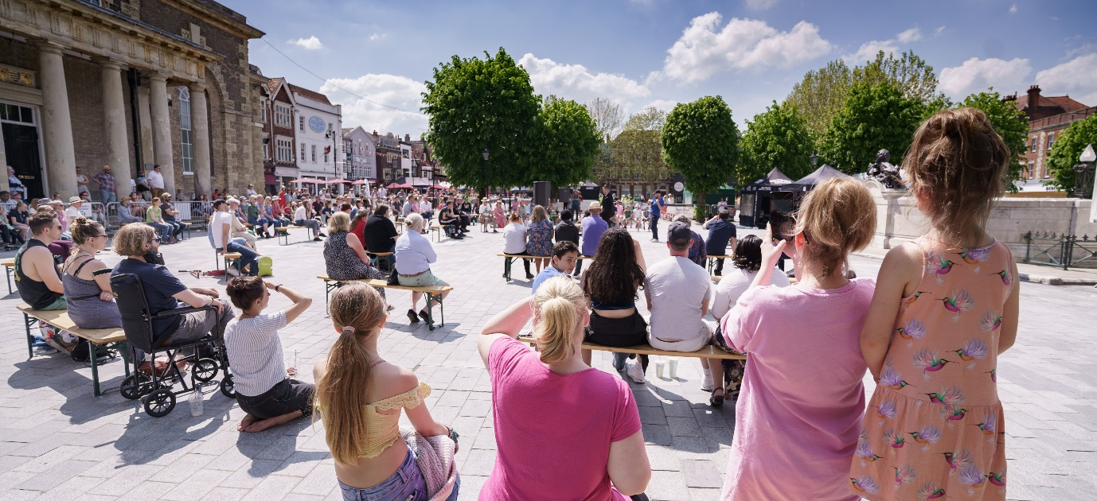
City Encounters 2021 © Ash Mills

About the Board
Until April 2018 the Board of Directors was made up of representatives from each of the festivals that make up the Artistic Directorate. Prior to becoming an NPO, Without Walls reviewed its company structure and from 1 April 2018 a new Board was established, responsible for setting strategy, upholding vision and values, overseeing the work of the Artistic Directorate, the Associate Touring Network and the management team in accordance with the organisation’s constitution, legal and financial obligations. Board members are drawn from the consortium’s partners, alongside independent external voices with an equal passion for the work of the consortium.
Find out more about the Board members here.
Without Walls currently has six Board Members drawn from the partner festivals, as well as six independent members who bring a different experience and perspective to the Board. Independent Board members have been identified through open recruitments in February 2018 and January 2019. The Articles of Association allow for up 15 Board members - seven Directors to be drawn from partner festivals, seven independent members, and the Chair.
Without Walls employs an independent executive chair, Josephine Burns, co-founder and Senior Associate of BOP Consulting, who is paid a nominal fee to oversee the Governance arrangements, chair the meetings of Without Walls Board and other network meetings, and to oversee and support the work of the Management Company.

Artistic Leadership
The Artistic Directorate has delegated powers from the Board to select the artistic programme and provide artistic leadership to Without Walls. Three members of the Artistic Directorate currently sit on the Board.

Management and Delivery
The strategic development and day to day management of the network and delivery of its activity is managed by XTRAX, an independent management and production company based in Manchester. XTRAX was a founder member of Without Walls in 2007, but stepped down as a partner festival in 2011, and now has a delivery contract with Without Walls, taking responsibility for delivery of the work outlined in the Business Plan and reporting to the Board of Directors and other networks. The Director of XTRAX and other senior staff report regularly to the Independent Executive Chair of Without Walls.

Appendix 2

Without Walls Business Plan Aims (September 2021 Edition)
Between 1 April 2022 - 31 March 2023, Without Walls will deliver an artistic programme and projects in support of six aims. Each aim has been addressed by the delivery of several objectives, each in turn supported by a detailed series of actions.
The six aims are:
- To commission and tour a diverse range of ambitious outdoor arts shows
- To invest in talent through research and development, mentoring, producer support and learning opportunities created by and for artists
- To lead targeted initiatives to address strategic needs in the outdoor arts sector
- To deliver pioneering audience development approaches to extend the reach of outdoor arts to all communities, particularly in the hardest to reach communities in England
- To advocate and promote the consortium’s work across the UK and internationally
- To support the sector by sharing knowledge and leading research into sector issues
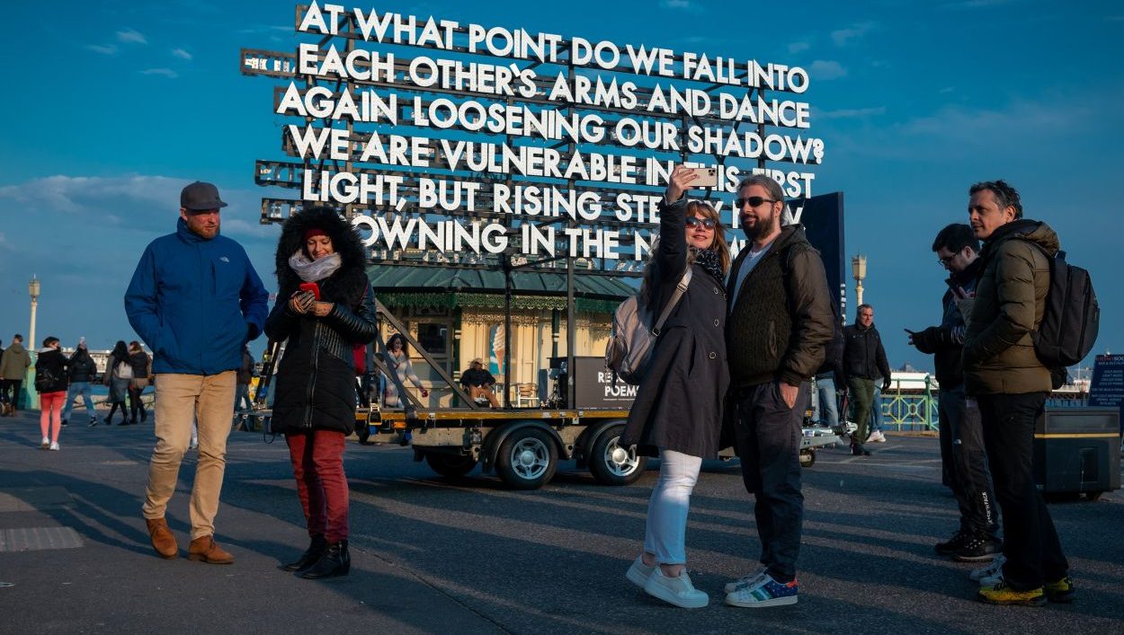
Recovery Poems by Emergency Exit Arts © Alex Bamford Photography

Appendix 3
All of Without Walls activity is subject to internal monitoring processes and is regularly reported to Board members and stakeholders in a variety of ways. In addition to ongoing internal evaluation and reporting processes, led by the staff at XTRAX and including feedback from artists, festivals and other participants, Without Walls also commissions audience data reporting from The Audience Agency and has engaged external consultants to review its work in particular areas.

Available Data Sources (other data can be made available if required)

Audience Data:
- WW Associate Touring Network (ATN) and Touring Network Partnership (TNP) reports 2018, 2019, 2021 – The Audience Agency (TAA)
- Summary / benchmarking of audience data collected via Touring Partners at their events
- WW Artistic Directorate reports 2019, 2021 - TAA
- Summary / benchmarking of audience data collected via Artistic Directorate Partners at their events
- WW report 2019, 2021 - TAA
- Comparison of audience data across the Touring Network Partnership and Artistic Directorate
- Outdoor Arts Audience Finder Year 2 Report 2018 - TAA
- Sector data, from Audience Finder. A large proportion of the data used in this report comes from WW festivals
- WW Impact & Insight Reports 2019, 2021 – Culture Counts

Project and Financial reports:
(prepared internally or by Without Walls partners and stakeholders)
- Mid Point Review – WW activity 2018 /19 and 2019/20 including financial statements
- Annual Review – WW activity 2020/21 and financial statements
- Evaluation Reports for ATN/TNP/AD 2018, 2019, 2020, 2021
- WW Business Plan 2018 – 2023
- Board reports
- Festival Evaluation surveys for AD partners 2018, 2019, 2020, 2021
- Festival Evaluation surveys for ATN / TNP partners 2018, 2019, 2020, 2021
- Staff festival visit forms – internal (Commentary on festival events)
- Application forms and summarised data from supported artists 2018., 2019, 2020, 2021
- Application forms and summarised data from Blueprint (R&D) projects 2018, 2019, 2020
- WW Artist evaluation forms – supported artists 2018, 2019, 2020, 2021
- WW Artist evaluation forms - Blueprint (R&D) 2018, 2019, 2020, 2021
- WW Artist Evaluation forms - TNP / ATN 2018, 2019, 2020, 2021
- Financial reports - Management Accounts /, minutes of selected Finance and General Purposes committee meetings 2018, 2019, 2020, 2021
- Touring Pro-formas 2018, 2019, 2021 (prepared for ACE)
- A range of participant feedback forms from Training sessions, Creative Labs, conferences, placements and seminars between 2018-2021

Externally prepared or commissioned reports:
- Risk Ratings and Creative Case ratings / reports 2018, 2019, 2020, 2021 – ACE
- Governance Review 2020 – Culture in Flux
- Perceptions and Positive Action Review 2021 – Jeanefer Jean-Charles and Natasha Player
- Review of the Artistic Directorate 2019 – Michael Hoar
- Statutory Accounts (prepared by Slade and Cooper Accountants)
- ACE Let’s Create Strategy (including Investment Principles) 2020
This list is not exhaustive, and additional information may be available.

Appendix 4

Provisional list of interview subjects
- Jo Burns – Chair of WW Board
- Management staff at XTRAX
- Members of the Without Walls Board, Artistic Directorate and Touring Network Partnership
- Catherine Mitchell – Arts Council England (Relationship Manager for Without Walls)
- A selection of sector leaders and artists to be agreed

